M5Stack Tab5 Hardware ID
by Bryan A. “CrazyUncleBurton” Thompson
Last Updated 2/19/2026

Prerequisites
You will need GitHub.com account to complete this tutorial. They are free.

Hardware

Microcontroller Dev Board
M5Stack Tab5

Install VS Code
Note: This section only needs to be done once per computer.
- Browse to: https://code.visualstudio.com/download#
- Download the VS Code for your OS. For Windows, use the one marked System instead of the one marked User and instead of the Windows Store version. It will install for all users and give you the ability to edit important files.
- Right-click the file you downloaded and choose “Run As Administrator”.
- Give the popup window permission.
- Accept the license agreement.
- Choose the default location to install VS Code.
- Click the Create a Desktop Icon and “Open with Code” options, then click Next and then Install.
- Leave “Launch Visual Studio Code” checked and then click Finish.

Configure Github User Info in VS Code
Note: This section only needs to be done once, at the time you install Visual Studio.
- Start a terminal by clicking Terminal/New Terminal from the menu.
- Issue this command, replacing “Your Name” with your GitHub User Name: git config --global user.name "Your Name"
- Issue this command, replacing your.email@example.com with your actual email address: git config --global user.email your.email@example.com
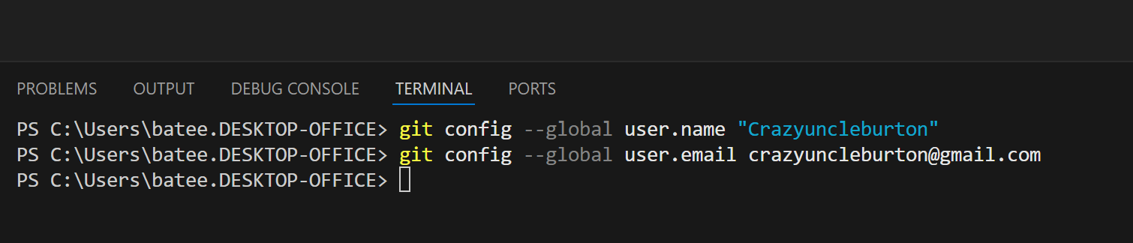
- Restart the VS Code app.

Install the Platform IO Extension in VS Code
Note: This section only needs to be done once, at the time you install Visual Studio.
- Open VS Code
- Click Extensions (left hand toolbar) 
- Search “Platform IO”
- Install the Platform IO extension.
- Trust Platform IO if needed.
- Restart VS Code if needed.

Install the MS C/C++ Compiler Extension in VS Code
Note: This section only needs to be done once, at the time you install Visual Studio.
- Open VS Code
- Click Extensions (left hand toolbar): 
- Search “C/C++”
- Install the Microsoft C/C++ Extension.
- It’s Microsoft, so no trust needed.
- Restart VS Code if needed.

Synching the GitHub Project
- Close all folders and projects in VS Code. File/Close Folder or File/Close Workspace will accomplish this.
- Go to the GitHub project here: https://github.com/CrazyUncleBurton/M5Stack-Tab5-Hardware-ID
- Click the green Code button and press the copy icon next to the URL to copy the URL to the clipboard.
- Go to VS Code and click the Platform IO alien logo in the left toolbar and choose “Clone Git Project” from the Quick Access pane.
- In the window that opens at the top center of VS Code, press CTRL-V to paste the URL of the project and then press ENTER.
- A dialog opens asking where on the local machine to put the folder that contains the project. It’s asking what folder it should put the folder that contains the local copy of the proect. The answer to this question is always “UserProfile\Documents\PlatformIO\Projects”. Just highlight Projects, don’t browse into that folder.
- Click the Select as Repository Destination folder.
- The project will be downloaded to the local machine and open in VS Code.
- Platform IO will download the managed libraries and install a compiler for this CPU type. This will take some time, as it is updating the ESP32 Platform to Core 3.x at the same time.

Testing
- Connect a USB cable from the computer that VS Code is running on to the M5Stack microcontroller.
- Connect a cable from the red port on the microcontroller to the red port on the ENV III sensor.
- If the microcontroller is not on, press the white button on the side once to turn it on.
- In VS Code, look at the bottom toolbar for the COM port icon 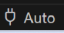 with hover text “set upload/monitor/test port” and click it.
- See if the device is present in the list that appears in the top center of VS Code. It should say USB Serial Device with some randomly assigned COM port that isn’t in use by anything else. Don’t choose the specific COM port – leave it set to Auto. Plugging the microcontroller into a different port can cause the COMxx number to change for the microcontroller, causing the program to not upload.
- In VS Code, click the PlatformIO Upload icon in the bottom toolbar. The hover text will be PlatformIO: Upload.
- The project will compile again. When it’s ready to upload, we see lines like “Connecting…” and “Writing…”. Wait for the line that says SUCCESS in green text before proceeding.
- When the upload completes the microcontroller reboots.
- You should see hardware info about the microcontroller on the screen.

Reference
Tab5 Microcontroller Info: https://docs.m5stack.com/en/core/Tab5
M5GFX Display Library Stuff: https://docs.m5stack.com/en/arduino/m5gfx/m5gfx_functions
M5Canvas Stuff: https://docs.m5stack.com/en/arduino/m5gfx/m5gfx_canvas

